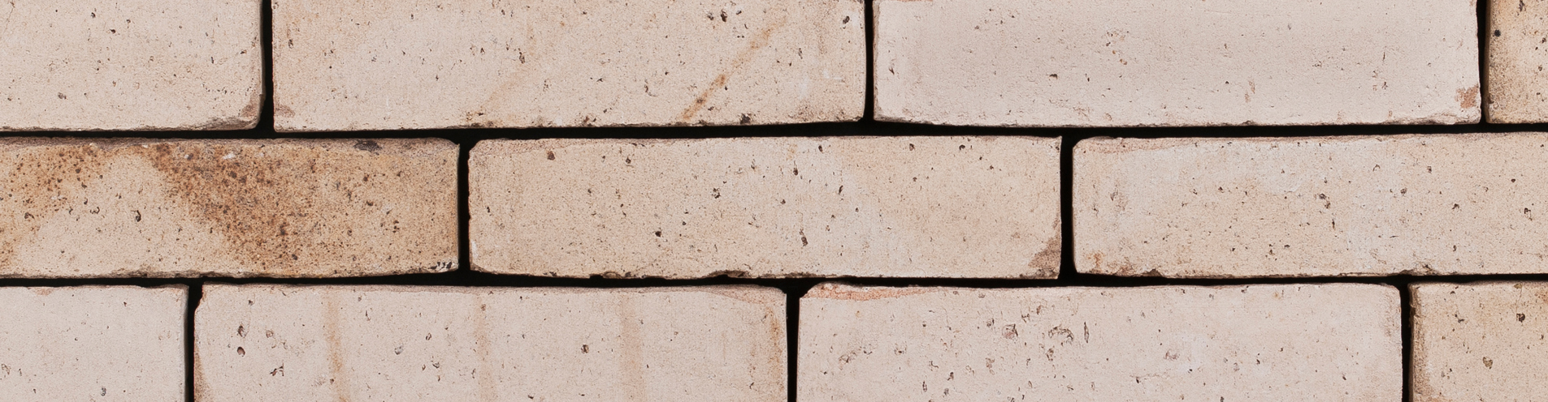

TEXTURE, TYPE & COLOUR
The decorative brickwork (inside and/or outside face) is made with a solid unsanded moulded brick without grain with a very uneven structure. Due to the natural reduction with coal the bricks have a strong fired rough field fire aspect. Some visible sides of the brick also contain traces of coal and of the manual production method. The colour of the body is cream and nuanced from cream to ecru.

RAW MATERIAL & PRODUCTION & VIEWS
This entirely natural product is made of alluvial clay from the Quaternary from the Scheldt valley. The brick is formed in a unsanded mould by putting in a lump of clay and is fired at at least 1150 °C. The facing brick is a solid moulded brick and has a homogeneous structure.It is free from lime and other inclusions and has at least one stretch and one head which are free from cracks and other aspects which negatively affect the overall appearance of the brickwork.

TECHNICAL CHARACTERISTICS
The facing bricks are delivered with the following characteristics, in accordance with the CE, UKCA and Benor marks:
CE mark according to EN 771-1: 2011 + A1: 2015 and UKCA mark according to BS EN 771-1 : 2011 + A1 : 2015
Manufacturing dimensions (L x W x H) | *227x74x55 mm
Quantity / m² with a traditional joint | ca. 63 (12 mm)
Number / m² with a thin joint | ca. 71 (6 mm)
Manufacturing dimensions (L x W x H) | *218x104x63 mm
Quantity / m² with a traditional joint | ca. 58 (12 mm)
Number / m² with a thin joint | ca. 65 (6 mm)
Size tolerance | Tm (+/-8/6/4)
Size spread | Rm (20/8/6)
Gross mass density | 1900 kg/m³ (+/- 20 %)
Avg. standardised compressive strength (cat I) | > 20 N/mm²
Water absorption (24 hours) | < 14%
Initial water absorption (1 minute) | < 4 kg/(m² . min ) IW3
Water vapour permeability | µ = 5/10
Thermal properties (λ10, dry, 90/90) | 0.60 W/mK (table 1 EN1745)
Durability (frost / thaw / resistance) | F2
Active soluble salts | class S2
Fire reaction | class A1
Bond strength (according to EN998-2: 2003 Annex C) | NPD (no performance determined)

Benor according to PTV 23-002 (additional properties required for Belgium)

Characteristics | In a sample of 100 bricks, at least 90 bricks will have one undamaged header face and one undamaged stretcher face. The number of defected bricks must not exceed 5%. The following are considered defects; the presence of hard spots which may swell and cause the brick surface to flake, cracks with a width > or = 0.2 mm that affect at least 2 edges. Any damage or defects must always be reported before use

TREATMENT COUNCIL
During processing the bricks should be mixed from 5 different packs. The bricks are stacked tower by tower.The right mortar composition must be determined in consultation with the mortar supplier. Fresh brickwork should always be protected.

*Dimensions may vary depending on the production. For the most recent version see www.vandemoortel.co.uk. This document is not binding and annuls all previous publications. The manufacturer reserves the right to change the product range and characteristics. The user must always check that he has the most recent descriptive text.

Productshot
