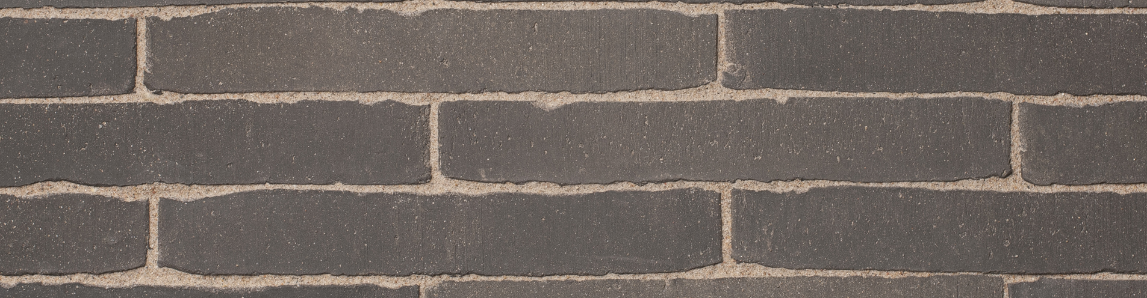

COLOUR
Dark grey

Product description
The bricks are formed individually in the unsanded mould to a solid mass, pressed from clay of alluvial origin from an area located in the Scheldt basin and fired in a tunnel oven at a temperature of approximately 1180°C. On the narrow side the bricks have an unsanded surface structure.

TECHNICAL CHARACTERISTICS
The pavers are delivered with the following characteristics, in accordance with the CE and UKCA mark:
CE label according to EN 1344 : 2013 / AC : 2015
Manufacturing dimensions (L x W x H) | *235x36x72 mm
Quantity / m² with a traditional joint | ca. 111

PHYSICAL AND MECHANICAL PROPERTIES ACCORDING TO EN 1344: 2013 / AC: 2015
Aspect | Class | Mean | Individual
Water absorption NBN EN771 | W3 | Max 5% | Max 6%
Transverse breaking load | T4 | Min 80 N/mm | Min 64 N/mm
Abrasion resistance | A2 (+) | Max 600 mm³ | Max 800 mm³
Frost resistance | FP100 | freeze/thaw resistant | freeze/thaw resistant
Wet skid resistance | U3 | >55
Acid resistance | C | < 7%
Size tolerance | R1 | Max. ± 0,4 vd | Max. 0,6 vd

Productshot
